Market Analysis Report for National Clothing Chain

## Introduction:

We are partnering with the National Clothing Chain with the goal of boosting their digital presence and increasing their sales focused marketing campaign. The National Clothing Chain recognized its recent low sales and is on a mission with us to tackle the issue and bring back their products’ influence in the market.

A key component of this project is the strategic marketing of a few products that are suited to clientele groups in various geographic areas. For this campaign, the apparel chain has selected three essential items: $25 shirts, $100 sweaters, and $1,000 leather bags. Choosing which product to market to each distinct customer segment while considering their preferences, purchasing patterns, and demographics is our challenge.

By utilizing analytical tools like Power BI, we have converted raw data into valuable insights that will direct The National Clothing Chain's marketing campaigns.

In this report, we will uncover the findings of our comprehensive analysis, unraveling the relationships between customer sales, income levels, product ratings, and return rates. By conducting a thorough analysis, our goal is to develop strategic suggestions that will drive The National Clothing Chain toward continued expansion and improved customer satisfaction.

## Findings:

After conducting a thorough analysis of the data provided by the National Clothing Chain, several key findings have emerged:

1. **Correlation Between Sales and Customer Demographics:**

Our analysis revealed a very strong positive correlation between income sales with a correlation coefficient of 0.78 using a linear regression formula, X= b-Y/-m. Specifically, customers in certain age groups and income groups demonstrated a higher propensity to make purchases, indicating that targeted marketing efforts should be tailored to these demographic segments. This could be seen in the scatter chart visual which illustrate the correlation and sum x (income) and y (sales) by each state. Further demonstrated that we added a matrix visual with the top 5 birth years with the highest income and another line chart visual of number of customers by range income.

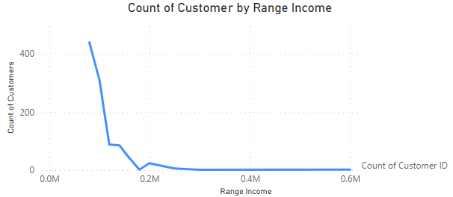 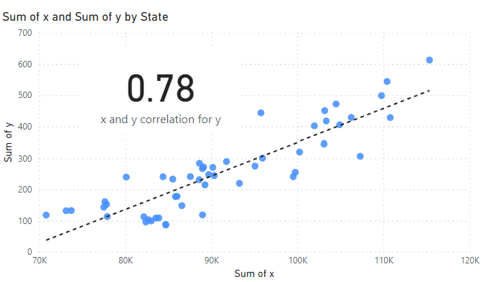

1. **Product Performance and Customer Satisfaction:**

Product ratings and return rates were examined to assess customer satisfaction levels. Products with higher ratings tended to have lower return rates, suggesting that customer satisfaction is closely tied to product quality. This underscores the importance of maintaining high-quality standards across the product lineup. For this part we used two visual cards to demonstrate the product with the highest performance and the number of return rates in total.

1. **Geographical Sales Patterns:**

Geographical analysis revealed variations in sales performance across different regions. Certain states exhibited higher sales volumes compared to others, indicating potential opportunities for targeted marketing campaigns in regions with untapped sales potential. For illustrating these findings we used two visual heat maps, one for average income in each state and one for the sum of predicted income.

1. **Customer Segmentation and Targeting:**

By segmenting customers based on various demographic and behavioral attributes, we identified the customer with the highest predicted income (Jon Little). This segmentation will enable the National Clothing Chain to tailor marketing messages and promotions to specific customer segments, thereby maximizing engagement and sales.

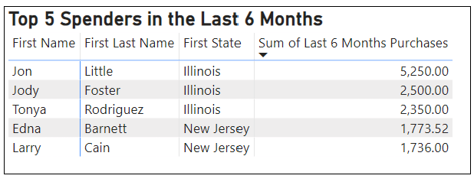

## Recommendation

* **Sweater Promotion:** Given the high recommendation for sweaters, it's crucial to prioritize their promotion in marketing campaigns. Emphasizing the unique features and benefits of sweaters, including their warmth, comfort, and style versatility, in marketing materials.
* **Leather Bag Promotion:** Given the lower ratings of the leather bag product, it is important to focus efforts on improving its quality and addressing customer feedback. Targeted marketing campaigns should prioritize promoting the leather bag, especially in higher income states where it may resonate with wealthy consumers.
* **Introduction of Chronograph Watches:** Based on their high ratings, Chronograph Watches present an opportunity for the National Clothing Chain to diversify its product offerings and introduce Chronograph Watches to the product lineup. Which gives it a chance to promote their unique features and design elements to attract discerning customers.
* **Customer Demographic Targeting:** utilize customer demographic data to refine and personalize marketing efforts, enabling the National Clothing Chain to effectively reach and identify high-income customer such as Jon Little, and tailor marketing messages and promotions specifically to this segment.